**SociALL. Making social care technologies accessible to all**

**WP2. Assessment of upskilling needs & Dissemination I**

**Activity 2.2 - Desk research**

**Austria**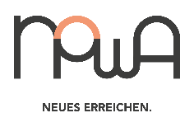

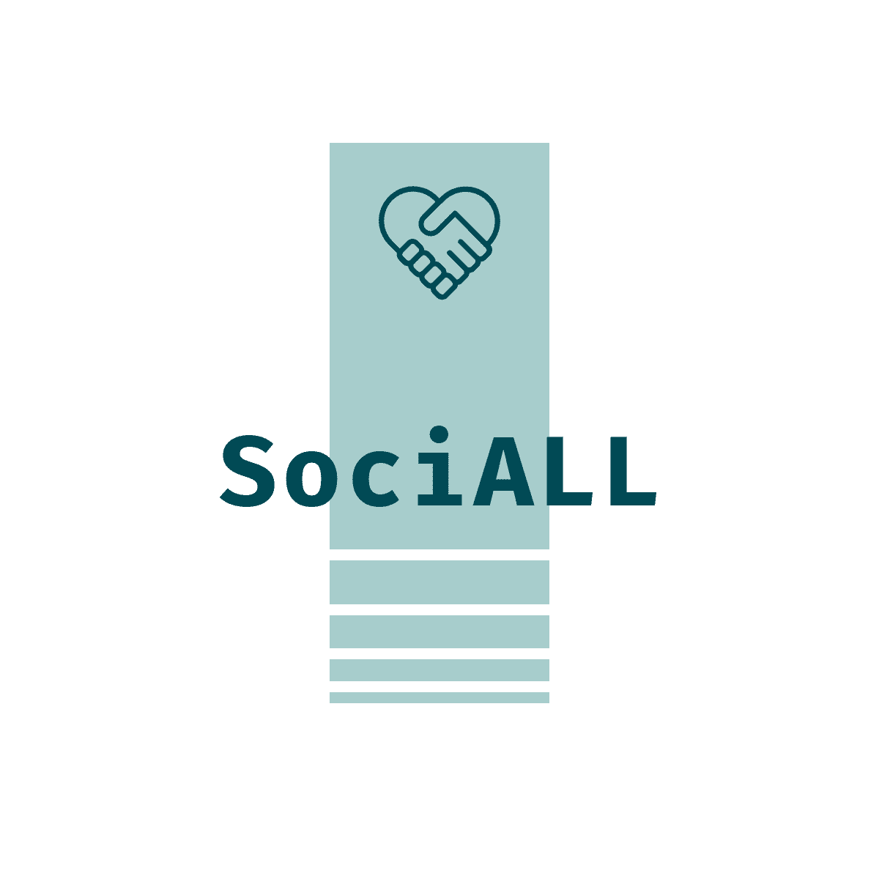

# **Introduction**

This research provides a representative overview of the professional care situation in Austria. It is based on a desktop research in the field of home care for the years 2016 till 2023 with a special focus on the Covid pandemic.

To obtain the needed data, the desk research focused on three areas of interest:

* General target group definition Austria
* Education of the target group in Austria
* Tech-related needs of care professionals in Austria

# **Care Professionals in Austria**

The responsibilities and the training system for health and social professions in Austria is very complex and not always uniform throughout Austria.

All professional groups and fields of activity presented here work in inpatient care such as hospitals and nursing/retirement homes, as well as in the field of mobile care, in which people who need support are cared for at home. There are different types of social care professionals in Austria.

“The professions are diverse and deal with the care and support of people of all ages, families and population groups in all forms and levels of care. The aim is to support people in such a way that physical, psychological and cognitive resources can be restored or maintained.”[1]

## Activities and Qualification of care professionals in Austria[2]

**Diploma in Health and Nursing** (Upper service for health and nursing)

* Carrying out activities and measures assigned by doctors
* Caring for people of all ages
* In different forms of care (mobile, inpatient,…)
* Work health-promoting, preventive, curative, rehabilitative and palliative
* University of Applied Sciences – Bachelor's degree (three years)
* School for health and nursing professions (until December 31, 2023)

**Nursing Assistant Professions**

***Care Assistant***

* Carrying out activities and measures assigned by qualified nurses or doctors
* Caring for people of all ages
* in different forms of care (mobile, inpatient, …)
* School for Health and Nursing Professions
* Course for nursing assistants (1 year)

***Technical Care Assistance***

* Independent implementation of activities and measures that have been assigned by qualified nurses or doctors
* Guidance and instruction of trainees
* Caring for people of all ages
* In different forms of care (mobile, inpatient,…)
* School for Health and Nursing Professions (2 years)

**Social care and support professions,** (home help, …)

usually have a focus in a specific field of activity, e.g. work with elderly people, family work, work with disabled/accompanying disabled people, everyday support, senior care, home support, etc.

Depending on the respective training and activity focus, they support people in need of care

* in activities of daily living
* in structuring and designing everyday life
* in housekeeping
* when dealing with authorities and making purchases
* in personal hygiene
* when dressing and undressing
* in exercise and leisure activities
* in promoting and maintaining flexibility and mobility
* etc.
* different courses and trainings

**Advanced medical-technical services**

These include, for example physiotherapy, dieticians and nutritionists, ergo therapy

* Independent application of therapeutic measures and different activities depending on the specialist area
* Advice and instruction
* Training, exercise and instruction in health-promoting measures and activities
* Implementation of measures ordered by doctors
* Universities of applied sciences – Bachelor courses

## General legal background

Health and Nursing Act, version of 03/01/2023[3]

# **Digital Skills in Care Professions**

Healthcare professions have been dealing with digitization for over 30 years. The shift from analogue files to electronic systems for documentation is a well-known example, not least because healthcare professionals currently spend between 15 and 70% of their working hours on administrative tasks.[4]

Digital technology seen as a driver in the following areas:[5]

* Networking, care teams, internal communication with colleagues
* Technology as an opportunity for demarcation and more emotional distance between nursing assistants or home help and clients
* Technology as a driver for “unlimited working hours

The smartphone or PDA (Personal Digital Assistant) can be named as the central technological working device. For nursing assistants and home help, the smartphone is used daily as a work tool and is made available by the employer with – relatively strictly limited – functions:

* mobile care documentation/mobile case and care management,
* route planner apps, other specific apps, such as "pharmacy apps",
* internal apps for the digital delivery and filing of wage slips, vacation requests, working hours, sick leave and similar,
* the possibility to take photos for documentation purposes,
* an encrypted system to gain access to apartments or key safes/digital unlocking system,
* contact lists of all colleagues for communication, number suppression for contacts with relatives and clients
* provision of an own e-mail address or a mail system
* setting up a video telephone system (due to Covid-19).

The fact that smartphones are being used comprehensively represents a new development in the organisations. The functions were gradually expanded, partly at the request of the employees, partly accelerated by the Covid 19 pandemic and the necessary contact restrictions associated with it.

Employees report in particular detail about the mobile care documentation / mobile case and care management: This contains the most important information about the customers to be visited as well as a list of "to dos" or special information per customer.

In addition, there are reports of customer security systems, some of which are also connected to the smartphone, some of which work separately.

Online team meetings and training were only introduced due to Covid-19. A specific app is reported here that was installed on the smartphone and allows participation in meetings or training courses using a code sent in advance.

In addition to one's own work equipment and its use, the customers' devices are also addressed, such as their smartphones, tablets or digital televisions. Here, assistance is occasionally necessary to support the customer with questions or problems.

Nursing staff often mention medical/care devices to customers.

Here they have apparently already developed a lot of routine and report rather “in passing” about the different work steps that they carry out here. This routine is also remarkable because there are many different models/brands of these devices in circulation and the employees therefore (must) have a considerable overview of which devices are currently in circulation and how to deal with functional and design differences.

## Needs and Necessities[6]

Health professionals already practicing and the generation currently studying and training are being “digitally socialized” primarily in the private sphere. However, this digital socialization does not necessarily lead to job-specific digital skills. Challenges such as the uncritical use of digital offers and the adoption of behavioural patterns from private everyday life can often be observed here. A well-known example of a digital misdevelopment is the uncritical use of WhatsApp in the healthcare system; from a legal and ethical point of view, its use in the treatment context is completely inadequate.

Different options for using technology in mobile care are largely mentioned in the following areas:[7]

* Networked route planning and activity recording: Planning and coordination of care assignments, optimized route planning and performance recording as a basis for billing
* Electronic care documentation: Electronic recording of patient data, organization and documentation of tasks
* Technical assistance systems: Use of technical applications in the living environment (Smart Homes, AAL - Ambient Assisted Living), e.g. sensors in the floor or in floor mats (fall detection), automatic stove switch-off and fire alarm systems, intelligent locking systems and access controls for the entrance doors, emergency call systems, etc.
* Telecare, use of offers in the area of telecare: e.g. B. Providing care instructions via a video connection, specialist diagnostics via a video connection, etc.
* Robotics: Use of a technical system that supports or carries out nursing activities and services fully or partially automatically, e.g. transport of medicines, robotic arms in care beds for raising or positioning people in need of care, cuddly toy-like robots for stimulating positive stimuli and emotions, etc.
* Care Apps: Apps on mobile phones, tablets or PCs, e.g. family groups, exercise instructions for physical mobilization or memory training, example films for care activities, reminders for taking medication, data collection and documentation, pharmacy locations or other medically relevant locations etc.

The unequal distribution of the different technologies is evident both in terms of the devices made available and the access to different programs and apps: depending on the hierarchical level, a distinction is made between which devices are made available to the employees and which programs and apps are accessible and usable. Nursing assistants and home help are also found at the lower end of the hierarchy in terms of equipment and access options.

While the robotics trends described above, as well as telecare applications, have hardly yet found their way into everyday care, various systems for electronic care documentation as well as networked route planning and service recording are at least in the test stage at companies of general interest or have already been largely implemented. Both of the latter systems are intended to simplify organization and replace manual paper documentation. Technical assistance systems, on the other hand, often turn out to be developed in ways that do not meet the requirements of the target group and are therefore unsatisfactory in use. Questions of data protection and ethical questions have not been adequately clarified.

## Digital technology in everyday work[8]

**Work tools:** Even if the occupations examined do not require a dedicated computer workstation, the employees use highly technical work equipment such as smartphones or other computers to carry out their tasks. We noticed that it was very important that these tools were not only used for technical data processing/documentation, but also very actively as a means of communication.

**Work infrastructure:** In addition to the work tools, employees are also surrounded by a high-tech work infrastructure. This is more difficult to observe in mobile care, where employees do not have a fixed place of work. However, the activities described for the maintenance of the smartphones and the remote-assisted troubleshooting of technical problems also give certain insights that mobile devices are not only used as direct work equipment, but also to create an immaterial technical infrastructure that is available everywhere.

**External technologies from customers:** In practice, this means for the mobile caregivers that they not only have to deal with various security systems, but also support the clients in the use of private digital technologies.

**Background technologies for organizing and structuring work:** This includes company-internal IT systems that manage all work processes and thus create the framework for the activities of the employees in many respects. Examples of this would be systems for resource planning or for the management of logistical components.

**Digital technology as a tool - which contents are required?**

* Basics and access
* Handling information and data
* Communication and collaboration
* Security
* Problem solving and learning[9]

In order to meet future challenges, healthcare professionals must also understand the change process triggered by digital transformation and acquire new skills. This includes understanding digital treatment concepts, learning practical skills and developing a reflective attitude. In the context of this fundamental examination of digital technologies, the competence-based further development of one's own role in the healthcare profession is of crucial importance.

There is currently no competency framework model for digitization and new technologies in nursing or for health professions. The digital competence model (DiComp) is a reference framework for digital competences, which, however, does not explicitly refer to healthcare. In the current version DigComp2.1, five competence areas (information and data competence, communication and cooperation, creation of digital content and security and problem solving). There are also various publications that deal with the development of competence profiles. However, these differ significantly in type, scope and target groups. These usually follow IT-oriented perspectives of health and nursing informatics and usually do not consider interprofessional aspects enough.[10]

# **Home Care**

## Definitions and context[11]

**Home Nursing**

Home nursing offers specialist care for patients at home. People of all ages with any illness are cared for. Care also includes the guidance, advice and support of relatives and other people involved in care.

It is only carried out by people who are authorized to do so by the relevant federal regulations (Health and Nursing Act).

Medical home nursing care is granted for one and the same insured event for a maximum period of four weeks. In addition, it can be continued after the chief or controlling doctor has given his approval from the social security agency.

Social home nursing care is organized as part of mobile nursing and care and is also offered for a longer period of time.

**Home Help**

The trained home helpers look after and support people of all ages, primarily through the following activities:

* Assistance with housekeeping
* Maintaining and promoting physical well-being, e.g. through support
* for hygienic measures
* when preparing meals
* with nutrition and adherence to diets under the supervision of a specialist
* Promotion of contacts in the social environment
* Accompaniment when dealing with authorities and doctors
* motivation to carry out daily activities independently etc.

**Care Assistant Professions**

Care assistant professions are divided into care assistants and technical care assistants. They support qualified health and nursing staff by taking on the tasks assigned to them in the care and nursing of people of all ages.

Care assistants work under supervision, technical care assistants can also carry out activities without supervision.

Care assistants perform the following activities, among others:

* Assistance with personal hygiene
* For decubitus prophylaxis and care (pressure burn prevention and care)
* Applying simple dressings and bandages
* Relocate the person concerned, for example to an armchair
* Administration of insulin injections

In Styria, mobile care and support services/home nursing are provided countywide by five organizations recognized by the state of Styria. These are:

* Caritas of the Diocese of Graz-Seckau
* Hilfswerk Steiermark GmbH
* Austrian Red Cross, Provincial Association of Styria - care and support
* SMP social medical nursing service home nursing Styria non-profit company
* Volkshilfe Steiermark non-profit company GmbH

The nursing and care services are provided by the three professional groups of qualified nurses, care assistants and home help from 84 support points/social centres.

The services range from help with getting up in the morning to personal hygiene, medication, mobility training, medical home nursing services (e.g. injections, tube feeding, changing bandages), support in household management till the guidance of caring relatives.[12]

**Development of the number of customers in Styria 2020-2021**

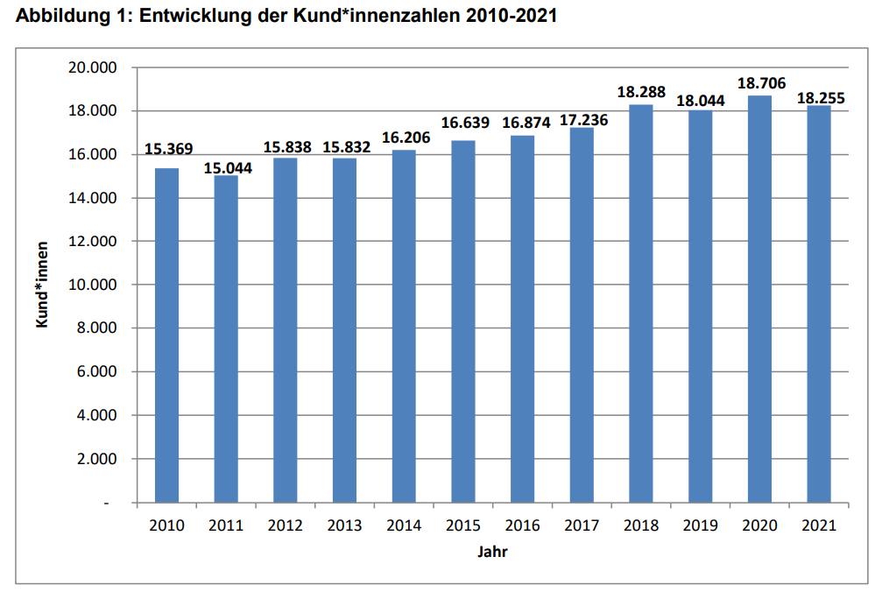[13]

There are also private care providers and self-employed individuals including 24-hour care.

## COVID Effects

In contrast to Germany, there are few studies on home care in Austria, most deal with the residential care.

While the guiding principle “Mobile before stationary” was laid down in Austrian long-term care policy – not least in the government program – this area in particular is also being neglected in the second wave of the pandemic. This area of care is not addressed either in the media or in the figures published by the government. Colleagues describe that this setting was long forgotten when creating recommendations for action, but also when providing protective equipment, screenings, etc.[14]

About 13%* of the people surveyed in the Corona Panel have relatives in need of care. About a third of them have a 24-hour caregiver, a third a part-time employee and another third do the care themselves - or the partners take over this task. It turns out that caring for family members is more likely to be done by women than by men.

Around 40% of those surveyed with relatives in need of care have experienced minor or major changes in the organization of care during the pandemic. In around 18%, relatives had to step in or help out with the care.

The problems with care were not limited to the lockdown period: at the end of June, about the same number of people had care problems as at the end of April.

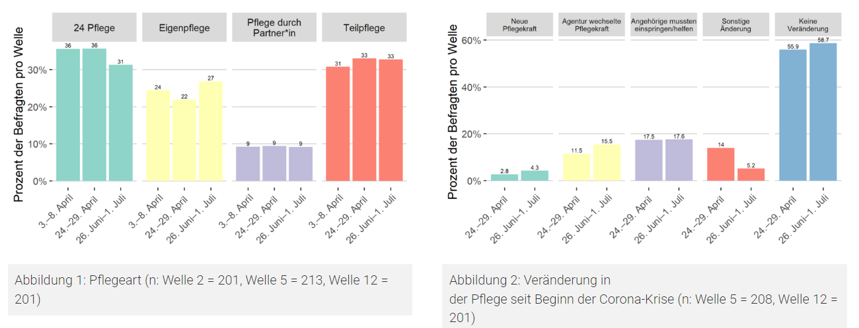[15]

*\*the numbers refer to 2020*

The COVID-19 pandemic is driving “a process that brings rapid advances in digitization and encompasses almost all areas of life (family, work, leisure, education system, health care)”. Digitization is a trend that “is mostly discussed in industrial production”. But also “in the body-related services, which are mostly performed by women, or in the care professions, a rapid growth in digitization through assistance and documentation technologies can be observed”

Digital technology is mainly used in a supporting function. “There are many apps in use that are used by care professionals. Or there is a glass with sensors that can measure whether a client is drinking enough water.”

The digital onboarding program is a good example of how digital technology can improve everyday working life. “For example, mobile care is very challenging. It requires a great deal of independence on the part of the colleagues. They drive to the clients and experience new situations there again and again, without backup as in the residential area. The onboarding app from the first day of work can help answer questions, for example about how I deal with difficult clients.” This tool is not only useful for the big players in the care sector, such as Caritas. "It can also support small organizations in training volunteers."

“In Germany we are increasingly seeing the trend of recognizing digital services as health services. The app is available there on prescription, for example if a specific app is supposed to help me with burnout prevention. Unfortunately, the health insurance funds in Austria do not yet offer this.”

New technologies can enable more tailored care. However, the COVID crisis has painfully revealed the lack of staff in the care sector. The population is getting older. More staff are already needed to maintain the existing level of care. A more individually designed care would require even more staff. And the state would have to spend money on that.[16]

# **Education of the target group in Austria**

## Status quo

An examination of the training plans of the **university of applied sciences** courses for health professions in Austria provides the following data:

Teaching content on digital technologies is given little or no consideration. Only 26% of all study programs considered have digital technologies as training content. In four out of nine health professions, digital training content could not be identified in any of the courses offered in Austria. Appropriate training content is available in five out of nine health professions, but not across the board in all degree programs in the health profession (e.g. in occupational therapy: eight programs were identified, only one of it has digital content in the training plan). Conclusion: In the curricula of the health professions at universities of applied sciences in Austria, digital skills are only insufficiently or not comprehensively represented.[17]

**Care Assistance**

If you look at the training ordinance, it is mainly "classic" care skills that are formalized here. This content of the training is divided into theoretical and practical aspects. The practical part of the training includes the following topics: Principles of professional care, care process, relationship design and communication, basics of medical diagnostics and therapy in acute and long-term care including medical care technology (two-part), basics and principles of acute and long-term care including care technology, Cooperation, coordination and organization, development and assurance of quality and learning area training and transfer. The practical training includes internships in the areas of acute care, long-term care, an elective internship and theory-practice transfer including practical reflection. The only explicit mention of digital skills can be found in the theoretical area under "Care process I (including IT)". In the specification for this area, learning how to use IT as a work tool is assigned to the sub-area of care documentation, specifically this partial aspect of the documentation is named “automation-supported IT and data protection”. Also in connection with IT use are the activities “Basics for writing factual, informative nursing report entries (formulating comprehensible texts)” and “Documentation in the proof of implementation”. These are the skills required to work with the app used via the PDA. The topic of data protection can also be found as an example of guidelines to be learned in connection with care documentation. There are no other explicit mentions of digital skills in the training ordinance or in the specification.

**Home Help**

Among the training content presented, there is not a single reference to the teaching of digital skills. Among the teaching objectives listed is the topic of “work organisation, planning and documentation”, an area of activity which, in the course of the evaluation of the interviews, turned out to be heavily supported by technology. Furthermore, in the course of a separate analysis of the data collected, it was shown that activities to reduce the risk of a Covid infection in the course of care work, which can be assigned to the teaching objective "Basics of applied hygiene: hygiene as self-protection and protection of others", can also be partially take place using technological tools.

**Technical schools for social professions**

Teaching digital skills

* Business, Information Management and Law", which includes the topic "Information and Office Management".
* Be able to use the Internet in a meaningful way to obtain information in compliance with the legal terms of use
* Independent use of "user programs", the use of communication technology and the procurement of information via the Internet are part of everyday activities
* Data protection is mentioned as another digital competence made visible on the basis of the data material.
* Ability to document and process practical experience in writing using modern media independently and on one's own responsibility.
* Language and communication" are roughly the teaching of the skills "to be able to use the new media, especially the Internet, critically"

The document analysis makes clear that digital skills as a basis for technological work are in some cases part of the training regulations examined. However, if the findings from the two training ordinances are brought together, a hiding mechanism becomes visible. The training regulation for care assistant professions aims at the specific qualification to practice the profession of care assistant. If one looks at the formalization of the care assistant profession via the defining activities, there is no sign of technological work among these. The presentation of the training content (probably for this reason) also provides little teaching of digital skills, such are explicitly mentioned above all in connection with the activity documentation. This is a central area of application of digital skills for mobile care assistants, but the analysis of the interview material shows that this is not the only facet of technological work in the everyday life of mobile care assistants. Compared to the formalization of the training content of care assistants, there are significantly more digital skills explicitly mentioned in the training ordinance for technical schools in the social sector. However, these are usually not framed as competences directly related to practicing a social profession. From this it can be deduced that the teaching of digital skills in technical schools is more an aspect of the objective of teaching general education and less a part of the ability to carry out “core activities” in (social and) care professions. However, the data material collected from the interviews makes it clear that the supposed general digital education in everyday professional life cannot be separated from the "core activities". The formalized presentation of vocational training for care assistants therefore does not include digital skills relevant to everyday work in mobile care, which are considered in the technical school for social professions in the context of the objective of general education.[18]

## Socioeconomic development of homecare in Austria

Care is female - since 85 percent of the cases are carried out by women. Surveys for the present study also show that around a third are over 50 years old and will probably be retiring in 10 years.

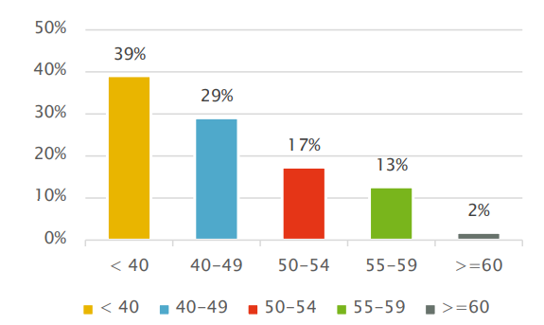[19]

Based on the surveys (survey period 2017) and considering the demographic development and the age distribution of the use of care and support in hospitals and in the area of long-term care, an additional need of 31,400 persons is assumed in Austria in 2030. This additional need increases to 34,200 persons if it is assumed that informal care will decrease and that mobile care and support at home will be expanded in the federal states in response. Since around a third of caregivers are over 50 years old and will no longer be working in 2030, it is to be expected that a further 41,500 persons will have to start working in order to be able to cover the demand.

That means for Austria

* an additional need of 34,000 persons due to the increase in older people and an expansion of care and support at home (around 13,000 more persons in hospital and 21,000 more persons in the long-term care area)
* coverage of retirements for 41,500 persons
* in total: 75,700 more persons by 2030

In order to be able to meet the future needs in the care sector, a wide variety of measures must be taken:

* innovatively plan and provide sufficient training places
* make care professions known, improve their image and increase their attractiveness
* specifically address different target groups and support them during the training
* design information events, internships and trial days in a sustainable way
* make it easier for foreign staff to start their careers
* reduce drop-out rates during training
* facilitate life-phase-appropriate work through skills and career development and promote an appreciative corporate culture
* (further) develop overall concepts and structures in facilities, implement and evaluate the GuKG amendment (Health and Nursing Act)
* ***conduct an in-depth examination of the possibilities of digitization to support nursing and care staff***
* promote networking and (trans)regional exchange
* use the potential of interprofessional training and cooperation
* develop new support and care arrangements

By 2030, the number of people over 85 will increase by almost 45 percent to 327,000 people, with the group of 85 - 89 year olds growing the fastest at over 50 percent.

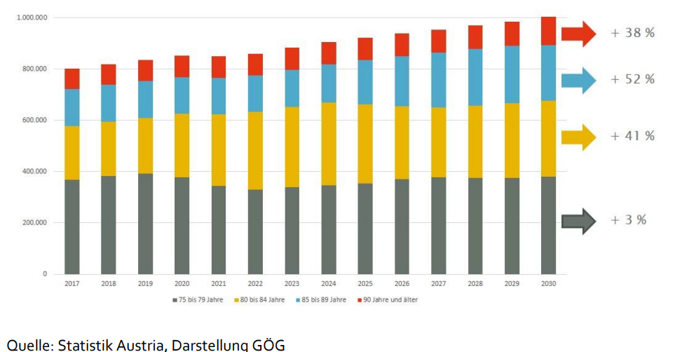[20]

## Educational opportunities in Austria

Each of the nine federal state offers corresponding training opportunities in care, these are regulated nationally in the Health and Nursing Act, version of 03/01/2023.[21]

The federal and state governments are already taking steps to promote the qualification and training of nursing and caregivers to a large extent. Healthcare and nursing professions have been a qualification focus of the labour market service for years, in recent years the focus has been more on company-related forms of training, especially the Implacement Foundation. Since January 1st, 2019, in addition to the classic health and care professions (e.g. nursing assistant), training in schools for social care professions has also been eligible for funding via the skilled worker grant. Despite the overall decline in funding expenditure, an annual activity level of approx. 10,000 training participants will probably also be able to be achieved in 2019 (as in previous years) within the framework of this AMS qualification focus. However, increasing the number of training places on offer alone is not enough. Due to the decline in young people overall and those who start nursing training, further measures must be taken.[22]

# **Tech-related needs of care professionals**

## Use of digital technology in Austria

E-health applications can make a significant contribution to stabilizing health systems. The current COVID-19 pandemic highlights the importance of digital solutions and skills in overcoming the crisis. The COVID-19 crisis has shown, especially for the Austrian healthcare system, that digitization is essential for maintaining medical care. In the Digital Economy and Society Index (DESI), an index developed by the European Commission to assess the development of the digital economy and society, Austria ranks 13th, slightly above the EU average.

Measured by the Digital Health Index, which assesses the degree of digitization in the healthcare system, the Austrian healthcare sector is not among the best in terms of digitization. However, the health sector has caught up, as digital measures such as digital advice and information as well as sick leave administration for employees were quickly implemented.

The rapid development of digitization and e-health applications require corresponding digital skills from health professions, especially professional care. Digital skills are necessary for caregivers to be both open to technological innovation and to manage the amount of information available.[23]

An example is the digital health strategy of the GGZ (Geriatric Health Center) Graz. It shows that tools are primarily used to improve or maintain health and to support older people in their home environment. Examples of successful projects in this context are therapeutic computer-based health training for seniors in the day center and teletherapeutic aftercare for geriatric patients.

The examples given are offers for patients who are covered by the care staff and require corresponding know-how - appropriate training is also offered.

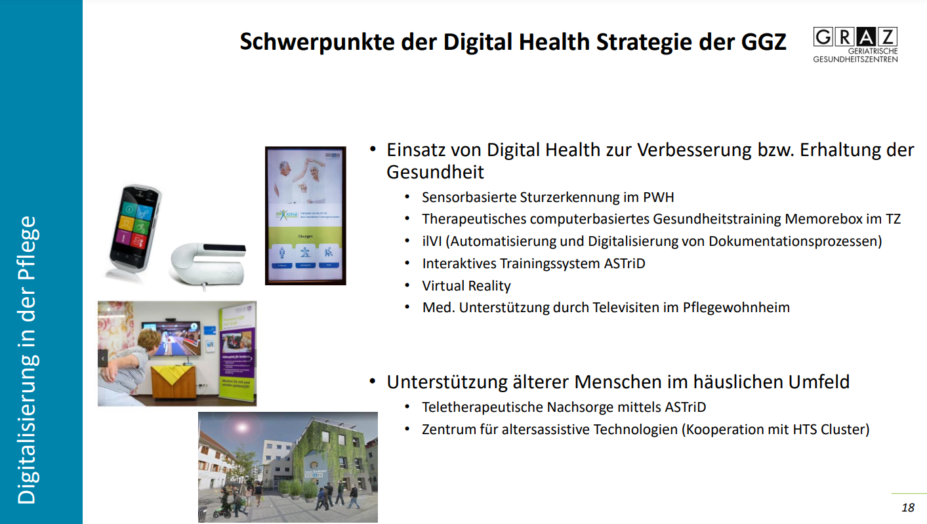

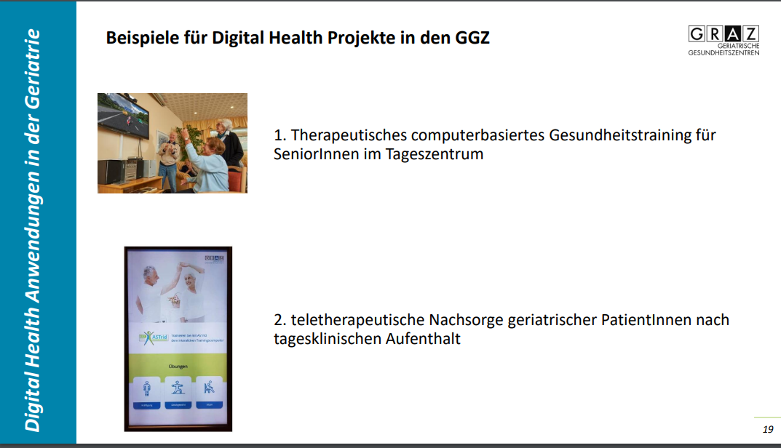 [24]

***Further best practices are collected during the interviews.***

## Needs for digital technology in Austria

A total of four care policy measures are listed under the heading “Opportunities of digitization” (current government program 2020-2024:

1. Making every day work easier
2. Examination of the use of the existing e-card system for care services
3. Possibility of anonymous use of care data for scientific purposes and for the further

development of the care system, taking data protection into account

1. Establishment of a comprehensive information platform for those affected and their relatives: Information should be made more readily available

So how can digitization make every day work easier – that means good conditions for good care, both for those who provide care work as specialists or relatives and for those who need care? If digitization is actually to contribute to making every day work easier, the central issues surrounding the conditions for good care must be the focus of the debate. In any case, the following three steps are necessary:

Step 1: Identify goals instead of means of digitization

Step 2: Develop needs-oriented technology together

Step 3: Shaping the framework for digitization

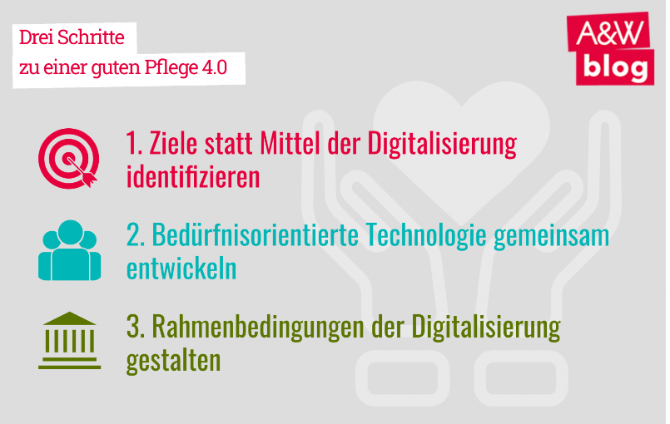 [25]

It's not just about one's own digital skills, being able to use mobile devices for documentation purposes or the like. Interviews with mobile care assistants have also shown that technical explanation skills are often required - for example, if the person being cared for wants or should use digital technologies themselves and needs support.

upgrade

In a further step, the researchers examined how these technological skills are taught. And the analysis showed that in the training regulations for care assistants and home help, digital competence is understood as a supplement to the "core competencies" of the respective professional fields. For the authors, however, this separation makes little sense. Finally, technological parts of the work are often core activities.

According to the authors, a first step towards upgrading would be to make the diverse skills of care assistants and home help more visible. Because the prejudices that these professions require little or no competence are largely responsible for the assessment of these professions.

Another type of professional upgrading could also be achieved by actively involving the employees in the design of technical processes of work organization, according to the research work.[26]

***Further best practices are collected during the interviews.***

# **Main findings**

* Healthcare professionals currently spend between 15 and 70% of their working hours on administrative tasks.
* Digital socialization in private sphere does not necessarily lead to job-specific digital skills.
* Digital skills are often not a cross-cutting issue in vocational training for care givers.
* The smartphone or PDA (Personal Digital Assistant) can be named as the central technological working device. For nursing assistants and home help, the smartphone is used daily as a work tool.
* The fact that smartphones are being used comprehensively represents a new development in the organisations. The functions were gradually expanded, mainly in documentation, coordination and organisation.
* It is a chance and challenge that these mobile devices are used not only for technical data processing/documentation, but also very actively for communication and information management.
* Nursing assistants and home help are found at the lower end of the hierarchy in terms of equipment and access options although they need it to a large extent due to their mobile activities and closeness to customers.
* Anytime, anywhere access to work infrastructure, such as remote access to relevant papers and documents is important in mobile care, where employees do not have a fixed place of work.
* Mobile caregivers support their clients in the use of private digital technologies. This requires technical and methodical didactic knowledge.
* Due to the working environment (mobile support, customer equipment, etc.), professional handling of data protection and security on the Internet is essential, not only to protect customers but above all to protect the carer givers.

1. Compare: <https://www.sozialministerium.at/Themen/Pflege/Pflege-mit-Zukunft.html>
2. Compare:

   Gesundheitsberufe in Österreich, 2020; Bundesministerium für Soziales, Gesundheit,

   Pflege und Konsumentenschutz (BMSGPK);
3. Compare: https://www.ris.bka.gv.at/GeltendeFassung.wxe?Abfrage=Bundesnormen&Gesetzesnummer=10011026
4. Compare: https://healthcareengineering.at/digitale-kompetenzen-fuer-gesundheitsberufe
5. Compare:

   https://wien.arbeiterkammer.at/service/digifonds/gefoerderte-projekte/EB_Versteckte_technologische_Arbeit_Dez2021.pdf
6. Compare: https://healthcareengineering.at/digitale-kompetenzen-fuer-gesundheitsberufe
7. Compare: https://wien.arbeiterkammer.at/service/digifonds/gefoerderteprojekte/EB_Versteckte_technologische_Arbeit_Dez2021.pdf
8. Compare:

   https://wien.arbeiterkammer.at/service/digifonds/gefoerderte-projekte/EB_Versteckte_technologische_Arbeit_Dez2021.pdf
9.
10. Compare: https://healthcareengineering.at/digitale-kompetenzen-fuer-gesundheitsberufe

    https://epale.ec.europa.eu/de/resource-centre/content/digitales-kompetenzmodell-fuer-oesterreich-digcomp-22
11. Compare: <https://www.oesterreich.gv.at/themen/soziales/soziale_dienste/1/Seite.1210120.html#:~:text=Aufgaben%20zu%20erf%C3%BCllen.-,Hauskrankenpflege,an%20der%20Pflege%20beteiligten%20Personen>
12. Compare: <https://www.gesundheit.steiermark.at/cms/ziel/72574635/DE/>
13. Compare: <https://www.gesundheit.steiermark.at/cms/dokumente/11684303_76111478/f20781a5/Jahresstatistik_2021_Mobile_Pflege_und_Betreuungsdienste_final.pdf>
14. Compare: https://awblog.at/gesundheits-und-pflegesystem-am-limit/
15. Compare: <https://viecer.univie.ac.at/corona-blog/corona-blog-beitraege/blog65/>
16. Compare: https://www.arbeit-wirtschaft.at/digitalisierung-in-der-pflege/
17. Compare: https://healthcareengineering.at/digitale-kompetenzen-fuer-gesundheitsberufe
18. Compare:

    https://wien.arbeiterkammer.at/service/digifonds/gefoerderte-projekte/EB_Versteckte_technologische_Arbeit_Dez2021.pdf
19. Source: Register of health professions, surveys in the federal states, representation: GÖG
20. Compare:

    Pflegepersonal-Bedarfsprognose für Österreich, Eine Studie der Gesundheit Österreich GmbH im Auftrag des Bundesministeriums für Arbeit, Soziales, Gesundheit und Konsumentenschutz Wien, November 2017

    <https://www.sozialministerium.at/Themen/Pflege/Pflegepersonal.html>
21. Compare: https://de.wikipedia.org/wiki/Liste_der_Krankenpflegeschulen_in_%C3%96sterreich
22. Compare:

    Pflegepersonal-Bedarfsprognose für Österreich, Eine Studie der Gesundheit Österreich GmbH im Auftrag des Bundesministeriums für Arbeit, Soziales, Gesundheit und Konsumentenschutz Wien, November 2017

    <https://www.sozialministerium.at/Themen/Pflege/Pflegepersonal.html>
23. https://pflege-professionell.at/e-health-und-covid-19-digitale-kompetenzen
24. Compare: https://www.digitalcity.wien/wp-content/uploads/2021/05/Foresight-14_Kratky_release.pdf
25. Compare: https://awblog.at/drei-schritte-zu-einer-guten-pflege-4-0/
26. Compare:

    <https://www.derstandard.at/story/2000132547702/wie-viel-digitales-know-how-brauchen-mobile-pflegekraefte>

    https://wien.arbeiterkammer.at/service/digifonds/gefoerderte-projekte/EB_Versteckte_technologische_Arbeit_Dez2021.pdf