Desk research
SociALL. Making social care technologies accessible to all

WP2. Assessment of upskilling needs & Dissemination I.
Activity 2: Country desk research
Identifier | ÅPENHET AS  Norway
Time horizon | Data : 2020 to 2023.  Literature review (secondary sources): 2009 to 2023
Research objectives | Determine the real upskilling needs of care professionals in relation to the use of tech-enhanced tools and practices in the field of home care by:  - Understanding the professionals: who they are, what they do, how many they are, how distributed they are, where they come from, etc.  - Understanding their educational backgrounds and their digital skills and needs.  - Studying the current state of technology use by the profession  - Understand existing opportunities for adapting new technologies to their daily operations.  - Outline and warn about expecting challenges to foresee in such a digital transformation.
Research items | 1. Target group definition 3  1.1. Introduction 3  1.2. Roles and responsibilities 4  1.3. Impacts of the COVID-19 pandemic 6  1.4. Skills and digital needs 7  2. Educational and socio-economic trends 7  2.1. Educational background 7  2.2. Geographic distribution of the workforce 8  2.3. National coverage of health and social care needs 10  3. Tech-related needs of care professionals 11  3.1. Tech-enhanced functions of social care 11  3.1.1. Introduction 11  3.1.2. Functions of social care and digital implications 13  3.1.3. Main principles of assessment of digital solutions* 15  3.2. Tech-enhanced tools for social care 17  3.2.1. Piloting, communication, support, operations 17  3.2.2. Technology as a prevention tool 19  3.2.3. Technology as a social care instrument 22  3.2.4. Technology as a medical care instrument 22  3.2.5. Tech-enhanced tools for collective improvement 23  3.3. Common challenges 24  3.3.1. Change management 24  3.3.2. Bottom-up approach 25  3.3.3. Training 26  3.3.4. Material constraints 26  3.3.5. Interoperability 27  4. Conclusion 27
Research body | Target group definition  Introduction  Social care workers in Norway represent a range of professions performing social and healthcare services to people in need of such care. The below graph describes these professions and shows a simplified structural distinction between social services with a medical and health aspect (red) and solely social services (blue). In addition, it gives an overview of the most common social care professions and the main care services provided by the municipalities.  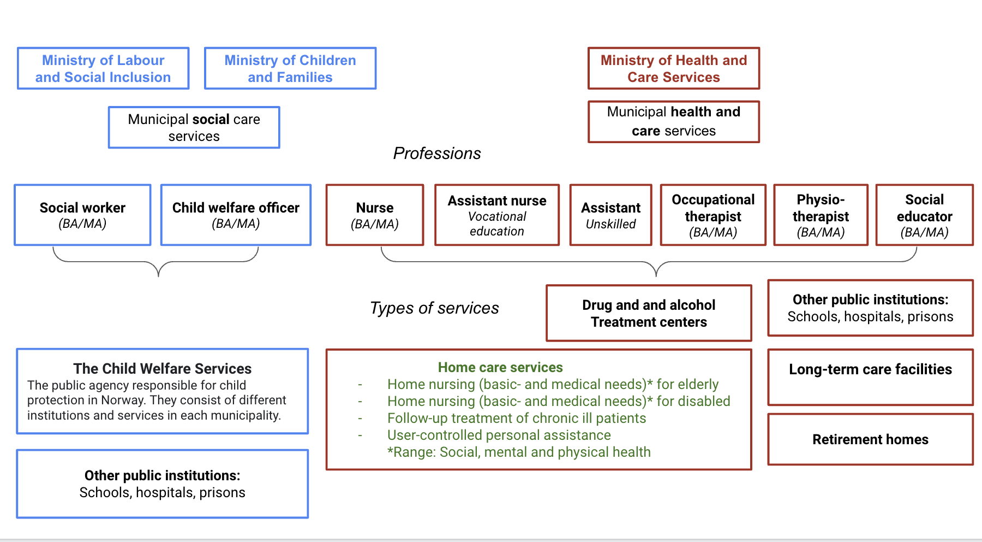  Figure 1: Norwegian health and social care professions. Source: Authors of this paper.  The Norwegian health care system can be characterised as semi-decentralised. The responsibility for specialist care lies with the state since 2002, administered by four Regional Health Authorities (RHAs). The municipalities are responsible for providing reasonable, high-quality health care and social services to everyone in need of them.  At the municipal level, there has been a shift away from residential to home based care. These services are intended for the whole population, irrespective of age, gender, socioeconomic status and other differences. In this respect telemedicine/welfare technology becomes even more important.  Roles and responsibilities  Home nursing, follow-up treatment of chronically ill patients and user-controlled personal assistance are among the main services the Norwegian home care sector provides. Home nursing care represents basic nursing and medical treatment for individuals, families, or groups in their natural settings within communities. Follow-up treatment of chronically ill patients is a service for citizens with chronic illnesses. With the help of technological solutions, patients can stay at home while municipal healthcare professionals monitor their condition. User-controlled personal assistance aims at giving people with substantial needs for assistance more freedom to manage their everyday lives themselves.  Within the home and residential care sectors operate nurses, occupational therapists and physiotherapists whose roles in this context would be the same as in other European countries and whose education includes at least a bachelor’s degree and state authorization to practise. Other professions within the sector include:  - Assistant nurses: Care for the user's need for holistic care, nutrition and basic nursing. They usually undergo vocational training before passing the state certification.  - Social Educators: Guide people with physical, mental or social disabilities through environmental adaptations. They usually hold a bachelor’s degree.  - Assistants: Around 25 % of the employees in municipal health care services are unskilled assistants. They receive training according to the service provided at their workplace. The most common tasks for assistants are basic social care and nursing.  The Norwegian use of the professional titles social worker and child welfare officers correspond to professions less represented in the care sector. This research will hence mostly focus on professions mixing social and health care.  Impacts of the COVID-19 pandemic  A recent study¹ from Oslo Metropolitan University states that the research literature published on COVID-19’s impacts on primary healthcare workers’ work is minimal. However, the hospitals’ prioritising of beds for COVID-19 patients caused an increase in the scope of activities of primary healthcare services during the pandemic. Furthermore, nurses in primary healthcare services were highly adaptable. Their willingness to adapt and sense of duty enabled them to take on extra responsibilities due to their position as frontline healthcare personnel.  According to the Norwegian e-health Directorate's 2021 annual trend report, the increased use of tech-enhanced tools during the pandemic led to accelerating an ongoing trend: digital tools like e-consultation, welfare technology and digital home monitoring became even more salient to reduce physical contact and ensure infection control. Besides, a need for entirely new digital solutions emerged to meet information needs and make testing and infection tracing work easier and faster. At the same time, infection-control policies delayed activities in several industries, including the health sector, with several projects and programs put on hold and treatments postponed. Finally, this rapid development of new solutions strongly challenged the management of sensitive information.²  The e-health directorate points to examples of increased collaboration, after the pandemic, between hospitals and municipalities. Furthermore, hospitals and municipalities have increasingly partnered with suppliers and academia to rapidly acquire new digital solutions, at a faster pace than before.  Skills and digital needs  Increased deployment of new technologies places new skill requirements among health and social care workers. They must now understand how to use digital tools to solve tasks in new and better ways. According to a survey by The Norwegian Association of Local and Regional Authorities, more than 4 out of 5 municipal health and care managers feel that their staff, regardless of their education, needs more relevant and necessary technological skills. There is a particular need to strengthen employees' education, innovation competence, and digital skills at all levels: in the use of professional tools tailored to the profession, but also in fundamental digital skills and, importantly, in the staff’s ability to learn and adapt to changes and digitalization trends.³  Educational and socio-economic trends  Educational background  Except for assistants, professionals of the target group require an authorization, granted through a national exam, to practise their specialty. Assistants, however, do not need authorizations: they are generally unskilled professionals receiving training in the workplace, depending on the activities they perform.  Although in need of an authorization, assistant nurses are not required to hold a university degree: an upper secondary school diploma in health studies, followed by a 2-year apprenticeship allows them to apply to the professional exam and, if passed, to become qualified healthcare workers. Some people, having worked in the health care sector for a certain time, can register directly to the professional exam, without going through the apprenticeship.  Both social educators and occupational therapists are required to hold at least a bachelor’s degree (180 ECTS) in order to apply for the national exam.  In addition to their bachelor’s degree allowing them to apply for the national exam, physiotherapists and nurses are required to complete a specialisation through a master’s degree (120 ECTS).  A total of 37 institutions offer education in the field of health care. They are represented in all counties, with the majority located in Oslo.  Geographic distribution of the workforce  Statistics Norway mapped healthcare graduates' place of study and settlement after graduation. The numbers show that proximity to higher education institutions is important in the choice of education and place of settlement. Compared to other graduates, most healthcare graduates completed their education within their county, or at least within the same region.⁴ As such, the health and social care sector workforce can be characterised as fairly distributed across the country, as exemplified in the following graph. Besides, its higher concentration in urban areas meets the actual disparity in coverage needs, as health and social care workers are more needed in areas generally connected with tenants’ eviction, i.e. urban areas.  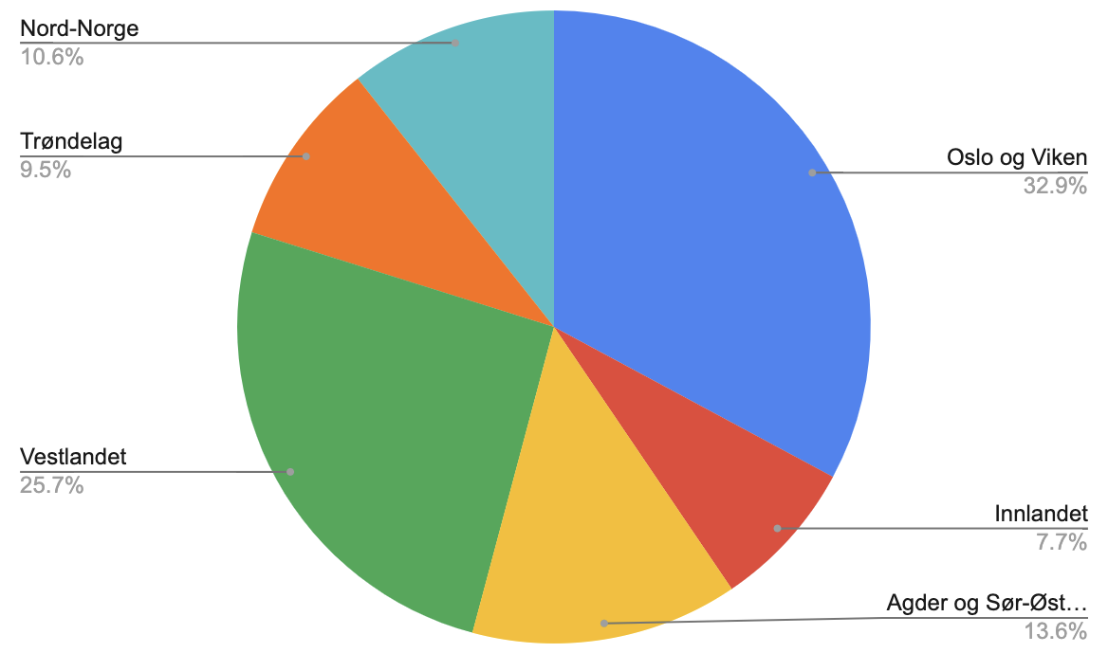  Figure 2: Distribution of social and health care professionals by region⁵  The demand for personnel working in hospitals and local government health and care services is highly dependent on the ageing of the Norwegian population. A considerable increase in the number of elderly towards 2040 is, therefore, one of the most critical factors behind the expected growth in demand for these groups. However, the impact of other explanatory factors is more uncertain. These include the degree to which health conditions for a given age are improving when life expectancy increases, the share of unpaid care at home, or the degree to which the number of health workers per user will continue to increase.  National coverage of health and social care needs  WHO data suggests that Norway ranks at the fifth position in the world in the number of nursing and midwifery personnel per 10 000 inhabitants, with a score of 188.3, as shown in the below graph.⁶  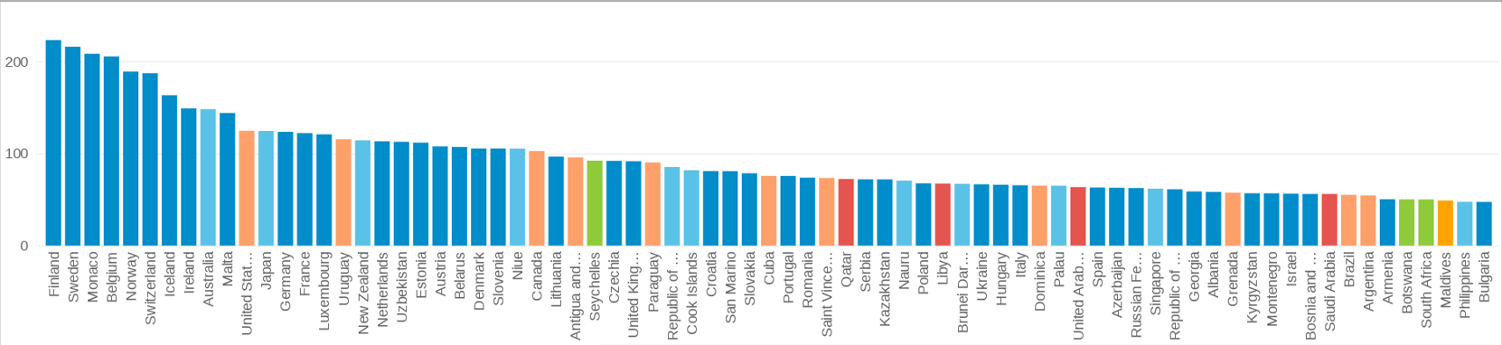  Figure 3: Nursing and midwifery personnel per 10 000 inhabitants  More precisely, Eurostat data from 2020 ranks Norway as the fourth country in Europe in terms of coverage of practising caring personnel, with over 1700 professionals per 100 000 inhabitants, largely above the European average (around 600).⁷ The Norwegian population can, therefore, be estimated sufficiently covered in terms of social care professionals, as shown in the following figure.  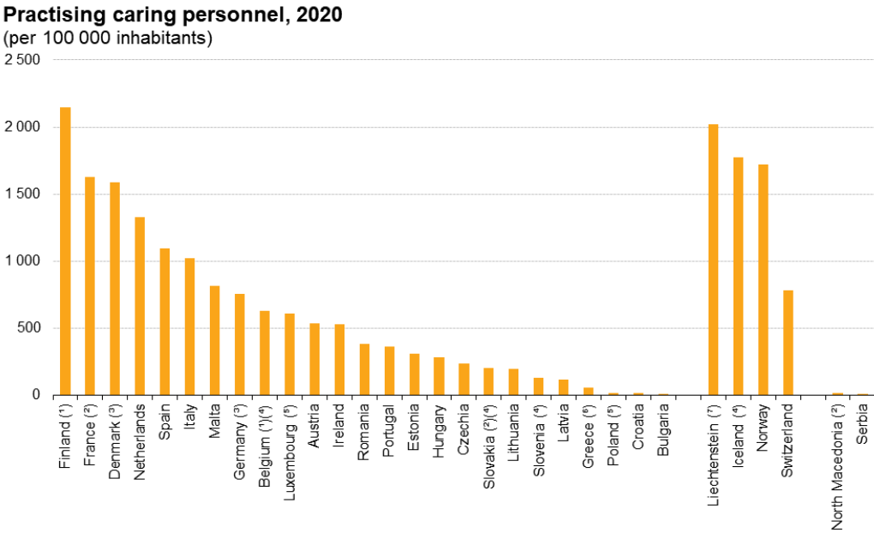  Figure 4: Practising caring personnel per 100 000 inhabitants (2020)  A noteworthy information lies in the gender balance of the profession: 82.7% of the healthcare workforce is represented by women.  Tech-related needs of care professionals  Tech-enhanced functions of social care  Introduction  Options of digital tools available and able to provide value to social care workers are virtually unlimited. As the sector has been growing rapidly across the world, countless software companies, entrepreneurs and social workers themselves have deployed various digital solutions catering to different needs of the sector’s professionals. Some large software editors have, indeed, specialised in this market and take pride in offering “all-inclusive” or “turnkey” solutions. As a matter of fact, the global home healthcare software market (encompassing only a part of what this research tackles) was worth more than 9.3 billion USD in 2021 and is expected to reach 22.3 billion USD by 2028.⁸ With these numbers in mind, it seems evident that technology can serve social care and is already doing so.  With such a large market, it becomes however complicated to situate oneself and visualise how technology can play this role, how to prioritise between technologies, how to avoid adverse effects of it, etc. The main question this benchmark tackles thus focuses on How: How can technology best serve the work of social care professionals? Far from definitively answering the question, this benchmark humbly aims at describing and classifying a selection of solutions, as a way of inspiring other social care professionals wondering how they could best make use of existing technologies.  Like in any information systems’ diagnosis and benchmark, study of digital tools and of their applicability in a particular context mostly depends on two sets of questions:  - What is the objective? What functions should the technology cover? What role should it play to bring the highest value to professionals of the sector?  - What is the context? Who should / could be equipped? How do they work now? What would they need to adopt new ways of working? Etc.  Only the answers to these sets of questions can properly inform decision-making about digital tools to adopt (or not) in the social care sector. Contexts of social care professionals are, by essence, related to their geopolitical situation: their work, the use they can make of digital technologies and the design of said technologies are fully influenced by laws, demography, health facilities, social support ecosystems, technical infrastructure, budgetary constraints, etc. that change from one country to another and often even vary between locations within a country.  To the contrary, objectives of social care are rather similar across geography. While professionals might be organised, compensated, educated differently, functions of social care are rather constant from one country to another. As such, the role technology can play to fulfil certain objectives and functions can be (cautiously) generalised - without forgetting important structural differences that persist.  Functions of social care and digital implications  An attempt to do so is presented in the below graph: Technology can mostly be used to fulfil 7 core functions of social care: piloting the activity, supporting the activity, exchanging and communicating, managing operations, preventing undesirable situations, social assistance and medical treatment. Each function can be further broken down into activities, for which specific digital solutions exist.  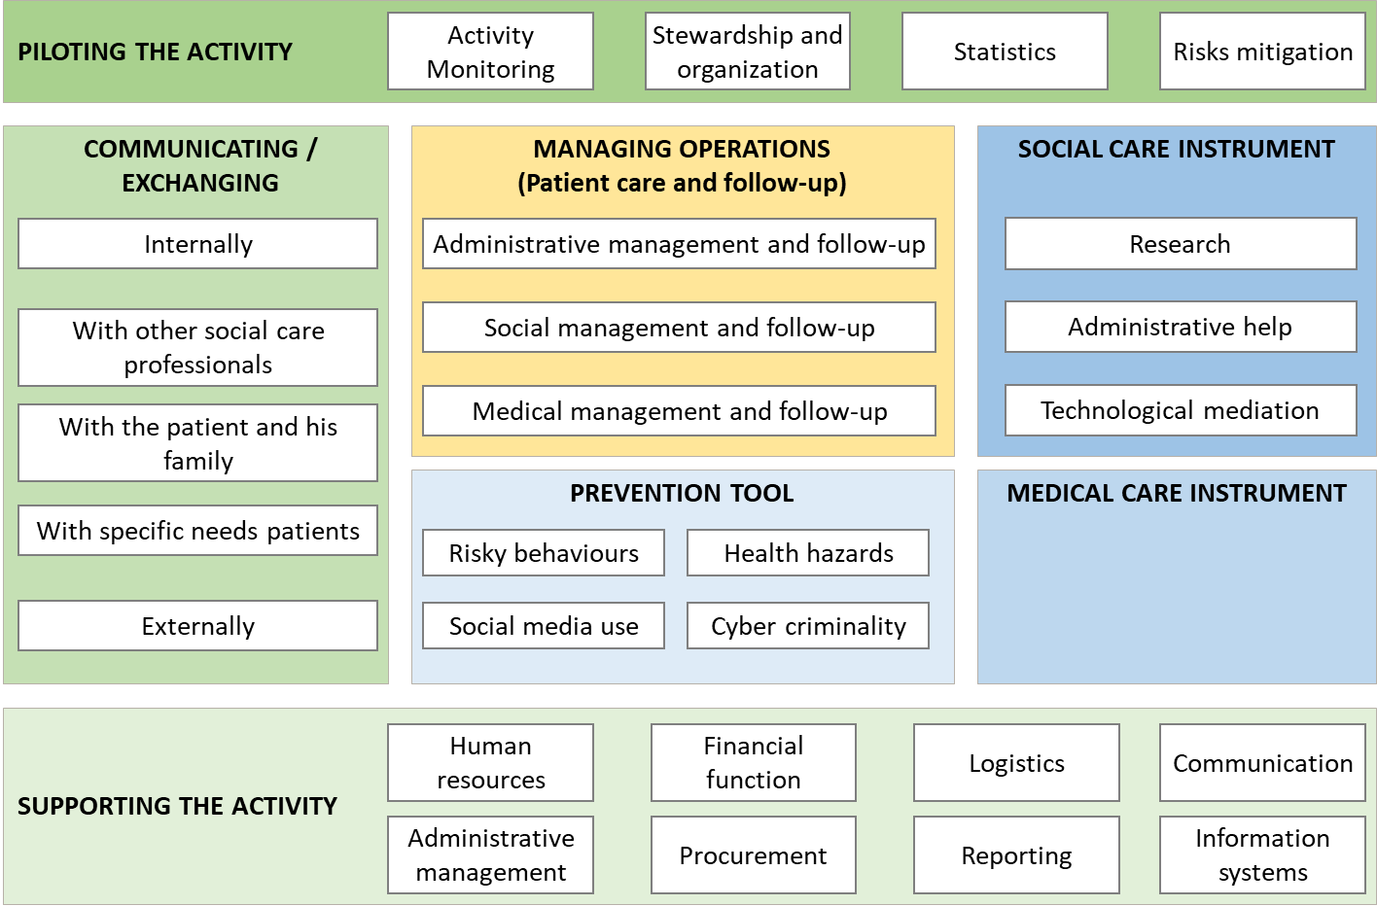Figure 5: Functions of tech-enhanced tools for social care. Source: Authors of this paper.  This breakdown into functions applies both for large structures (such as large municipalities’ social care services), small organisations and self-employed social workers, although their more limited needs might prompt them to renounce to tech-enhanced solutions for some functions, mostly for evident cost reasons. Although activities, tasks and volumes might greatly differ, the 7 described functions are normally covered by any social care organisation (sometimes simply with pen and paper). Similarly, these functions apply to home care and residential care alike.  The three functions of technology coloured in green in the above graph (“piloting the activity”, “supporting the activity”, “exchanging / communicating”) are functions traditionally found in any organisation, including outside of social care. Standard technologies (i.e. not specific to the social care sector) exist that can cover, to a certain degree, most of the activities included in these functions. Nonetheless, these solutions usually fall short of answering the specific needs of the sector and do not provide full satisfaction. In turn, large software editors that have specialised in the social and medical care sector usually provide adapted, customizable solutions that cover almost all the needs of these 3 functions. These “turnkey” solutions usually help centralise and manage all support functions (HR, finance, administration, procurement, etc.) and piloting activities (monitoring of activity, statistics, stewardship, etc.) while providing several options for different types of exchanges. Nonetheless, most of these solutions are developed in a country, for a country, as they are adapted to specific laws and regulations (labour, health, tax, data protection, etc.), fetch data from and send data to specific places (tax authorities, social security information system, etc.).  The function of technology for social care that is coloured in yellow (“Operations Management”) is, in most cases, covered by these large solutions as well, although not always entirely. It is however not, or only partially covered by standard technologies. This function is usually the most critical for social workers, as it is the one they will spend most of their time fulfilling: managing the patient care. As described in detail later, many existing solutions cover administrative, social and medical aspects of patient care, and bring value by making work more efficient, rapid, easy and transferrable. Similar to green-coloured functions, most existing solutions are tailored for a specific country.  Finally, the three functions of technology coloured in blue (“Prevention tool”, “Social care instruments”, “Medical care instruments”) represent the use of technology within care procedures: while “Operations Management” entails management of and follow-up on patient care, the blue-coloured functions deal with the delivery of the care itself. For these functions, there are as many existing technologies as there are care objectives: from sensor-based technologies to detect falls to low-tech methodologies to fight chronic anxiety. Most existing solutions are rather small and specific and their choice really depends on the treatment objectives. These three functions of technology for social care are also those for which innovation is most vivid, where new technologies are frequently invented and for which many solutions already exist but have simply not yet been implemented to new uses.  Main principles of assessment of digital solutions*  Regardless of the function they fulfil, digital solutions should be assessed based on a number of criteria. The most important criteria depend on the organisation itself and can therefore not be assessed in this benchmark. The below mentioned criteria (not exhaustive) are paramount to the success of any new information system’s deployment within any organisation: if any of the below questions is answered negatively, chances are that the selected tool will not bring about the expected results.  - Does the solution properly answer the organisation’s needs?  - Does it bring value to the staff?  - Does it make work easier / faster / better?  - Does it fit the organisation’s context?  - Does it correspond to the usages of staff and patients?  - Does it integrate the organisation’s legacy without loss or risk?  - Is it worth the price paid and the adjustments made ?  While answering the above questions is impossible in this paper, some annex guiding principles can still be integrated to the benchmark, as necessary features of most digital solutions that can be used by social care organisations:  - Conformity to regulations. For example, many regulations exist on the location that confidential health data is stored in. The USA being usually excluded because of intrusive regulations, many SaaS solutions are de facto unusable.  - User-friendliness. Is the solution easy to use and intuitive for the staff ? Even for the least tech-friendly staff members? For patients (if they have access to it)?  - Mobility. Can the same features be used satisfactorily on a tablet? A mobile? Is there an offline mode (often necessary for home care professionals)?  - Uses. Is there a desktop app, a mobile app and a browser version to cater to the different uses of the staff and patients?  - Hardware. What material or investment is needed for the staff to fully benefit from the solution? E.g. Is it available both on IoS and Android? In different browsers? Can it be used on personal computers or phones? etc.  Other criteria, not analysed in this benchmark (because of difficulty to do so from the available data) include:  - Cost. How much does it cost? What is the cost model? How high are maintenance costs? Is it worth it?  - Security. Is it solid and safe in terms of security? Are there reports of security failures? How critical to the organisation is it? Is there some communication / pedagogy to implement to reduce security risks?  - Integration: Can the solution be integrated with the other solutions used by the organisation? Can it even interact with other organisations’ information systems?  The solutions described later in this research paper have been partly selected based on the above-mentioned criteria. More importantly, we hope that these criteria will be upheld by any social care professional considering adopting new technologies, before investing or changing work processes, in order to increase chances of successful deployment and adoption.  Tech-enhanced tools for social care  Piloting, communication, support, operations  As described above, dozens of solutions exist to fulfil strategic, communication, support and operational functions. They are usually tailored for a specific country and vary quite importantly in prices and in detailed features. Interesting and significant examples include:  - Madweb for home care in France (Pulse Santé)  - Net-soins for residential care in France (Teranga Software)  More specifically, some solutions focus particularly on communication:  - Social Work Virtual Pal in the USA defines itself as the “LinkedIn of social workers”. It is designed to connect social workers, encourage peer-learning and serve as a resource for care-giving.  - Many tools exist to facilitate communication with patients presenting specific communication needs (e.g. blind or deaf patients, foreign language speaking patients, etc.). For example, SignAll has developed an automatic sign language translation system, endorsed by the EU.  - Alternatively, some solutions focus on the communication with the patient and his relatives. In Lincolnshire (UK), the Support at Home service developed a simple web-app allowing service users and relatives to be updated about the care delivery in real-time before the social worker’s visits (e.g. changes in planning, delays, etc.) and to provide real-time feedback on the care they received.⁹  - In Norway, KOMP is a widely used solution, helping patients that struggle with digital tools easily communicate with their families and friends, while its “Pro” version has proved efficient to improve communication with care providers, who can send messages to patients using KOMP, realise online consultations or remind them of their appointments through a calendar feature.  Electronic Health Record systems (EHR) are specific solutions tailored to help manage operations (yellow-coloured function). In Norway, it is worth noting the absence of a shared information model between primary health care entities and specialist healthcare entities, although they can collaborate through messaging. Main EHR systems used in Norwegian home- and residential care are:  - Gerica (Tietoevry) detaining 50% of the market.  - Visma Omsorg Profil (VISMA)  - Dips Arena (DIPS)  All EHR systems come with a smartphone-based solution allowing care workers to access the information they need outside the office. Users can obtain work lists and information on measures and procedures, they can write a journal on their mobile phones for ongoing use, or use specific functions for communication and coordination of assignments between employees in the service.¹⁰  Lifecare eRom (e-room) is a mobile module from Tietoevry used with adaptations to more specific needs within residential care units. It is already implemented in many Norwegian municipalities. E-room aims to provide a quick overview of the unit's rooms and its patients/users. In addition, quick access to treatment plans and the possibility to create documentation on touch screens inside the patient's room streamlines and ensures the quality of care workers' daily work.  Technology as a prevention tool  Using different technologies (GPS, censor data, artificial intelligence, etc.) and interfaces (phone apps, websites, bracelets, etc.), several tech-enhanced tools represent powerful prevention instruments for social workers.  A first category of technologies help detect health hazards in order to prevent their escalation or act rapidly enough.  - For elderly, many different technologies, most notably bracelets and ambient sensors, help detect falls and send an alert to the family, the social worker, the hospital, etc. in order for them to come rescue the patient rapidly. Many of these can even discriminate between “soft” and “hard” falls, thereby helping to prioritise and trigger appropriate responses. In Norway for example, many municipalities have opted for RoomMate or Tellu for both home and residential monitoring of elderly falls : based on infrared cameras and movement monitoring (no wearable device required), these systems activate alerts sent to care workers when a patient is detected to be on the floor, out of the bed, chair, etc.  - Other tools that can be used by social workers include trackers, notably of mental health issues: these mostly rely on the patient’s readiness to input data and can help track the patient’s evolution. For example, the mental health tracker MyCompass in Australia is showing conclusive results, allowing the patient to report mental health data and providing exercises and resources to help manage chronic anxiety or depression.  - Some technologies can prevent other types of health hazards using different sets of data from the patient’s environment. Crosscheck in the USA for example, is a phone-app preventing relapses in schizophrenia using a combination of observational and self-report data. It is able to detect the patient’s “relapse signature”, a specific behaviour unique to each patient and preparing the ground for a relapse. After detection of a relapse potential, the app can timely alert the treatment team.¹¹  - The e-lock is used in the home care service in Norway to ensure quick, secure and easy access to patients’ homes for social care workers. It consists of an e-lock, mounted on the inside of the door and invisible from the outside, that can be opened via Bluetooth from the social care worker’s mobile phone. Social care workers usually receive an electronic key access when they retrieve the work list of the day on their mobile phones. For users with prevention devices, the e-lock can reduce the time it takes to get assistance from the care providers.  Similarly, another category of technology helps detect risky situations from a more social perspective.  - For example, some technologies based on GPS data help detect socially risky situations and send alerts to relevant personnel, such as when a patient with a gambling or drinking issue comes close to a casino or a bar.  - Similarly, Frontline, an organization specialized in suicide prevention, has collaborated with Facebook to offer an innovative solution based on collective responsibility: a plug-in allowing Facebook users to report posts suggesting their author is at risk of suicide and suggesting follow-up actions (direct messaging, contact others for support, connect with a trained professional, a suicide helpline, etc.).¹²  Finally, technology can play an important prevention role by helping in the education of patients, most notably youth and usually through some kind of gamification. Use of the following two tools by social care professionals have proven effective in changing at-risk youth’s relationship with pedagogical resources and delivering important messages.  - For instance, Yale School of Medicine developed Play2Prevent, a video game teaching sex, drug and alcohol negotiation and refusal skills to 9-14 years old, in which the player is immersed in an interactive world where its decisions bear various risks and benefits, thereby preventing youth from engaging in risky situations unequipped.  - Similarly, researchers of UC Davis’ Foods for Health Institute developed GET-UP, a video-game linked to body activity monitors influencing game-play depending on the level of physical activity, in an effort to fight childhood obesity and to educate teens about personal health.¹³  Technology as a social care instrument  Different applications of technology function as a social care instrument. This function broadly comprises ways in which the social worker improves the wellbeing, social life and autonomy of the patient. It notably includes help in access to rights and administrative proceedings, mediation and autonomization of the patient on technology itself or mere research to find information useful either to the patient or to the social worker.  Social workers often help patients access their rights and undertake administrative proceedings. In France, social workers have the ability to use the Administration + platform: a secured e-communication platform for social workers and state operators only. It allows social workers, when their patient faces an administrative knot that can hardly be solved through normal channels, to use a privileged communication channel with the administration and solve the issue with a case-by-case discussion. As it is reserved to social workers, identified through a unique number, abuses are prevented, while complex administrative situations get more easily solved.  In many cases, technology as a social care instrument is rather low in terms of complexity. It can however, largely change the patient’s wellbeing. For example, countless cases have been reported of social workers simply installing Skype or Whatsapp applications on their patient’s devices and initiating them to it, in order for them to restore precious social ties with relatives.  Technology as a medical care instrument  The most innovative developments of tech-enhanced tools for social care in the last years revolve around medical aspects. While a few of them are outlined below, tech-enhanced solutions have been developed to cure, manage or monitor virtually any pathology or health-related issue.  - For example, Blues Buddy is a social network connecting people suffering from depression in the USA, encouraging them to reach out to each other, providing them with tools for dealing with challenges of their condition and enabling them to give and receive help from peers in a safe environment.¹⁴  - Another example of tech-enhanced tools includes the use of the (low-tech) video game Tetris as part of therapeutic treatment approach for posttraumatic stress disorder.¹⁵  - Alternatively, the University of Michigan’s School of Social Work created a computerised simulation to help transition-age youth with autism practise their skills in a work setting by repeatedly practising conversations with virtual customers, coworkers, and supervisors.¹⁶  - The most common tech-enhanced medical care tool used in Norwegian home care services is the medicine dispensing robot. It guides home care patients to take the right medication at the right dosage at the right time, as prescribed. Technical alerts such as "medicine delivered" and "medicine not delivered" can be automatically logged in the medical record system if it is integrated.  Tech-enhanced tools for collective improvement  Although not at the level of the individual professional, two further uses of technology are also important to mention, although not specific to this sector:  Training: As in other sectors, initial or continuous training of social workers can benefit from tech-enhanced pedagogical tools.  - A pilot study has, for instance, demonstrated that short audio recordings used as podcasts helped clinicians memorise and focus on particular objectives, specifications and methods to be used in their upcoming intervention.¹⁷ Berzin, Singer and Chan (2015) suggest this technique could be replicated with social workers, who also deal with various needs and situations, so that they listen to these recordings on their way to the patient’s home and arrive there fully prepared.¹⁸  - Alternatively, virtual reality, increasingly used in training, could also be applied to social care, with for instance avatars used to further enhance social work training and provide students training opportunities with feedback mechanisms.¹⁹  Advocacy, lobbying and awareness-raising: Like any professional group, social care professionals also undertake advocacy, lobbying and awareness-raising efforts to change regulations, perceptions, practices, etc. As for any advocacy and lobbying efforts, many tech-enhanced tools shall be considered by those leading campaigns to increase their impact.  Common challenges  Change management  In Norway as elsewhere, the vast majority of projects aimed at digitalising, modernising, equipping professionals, all sectors included but particularly in the health and social care sectors, do not reach their maximum potential and, in some cases, fail altogether, due to one simple misconception: technological solutionism, i.e. the assumption that a new tool or technology will solve problems by itself and be adopted by all because it answers to their needs.  In reality, even when a tool or technology is perfectly adapted to solve professionals’ needs, the key to its success is not its features, but its adoption and use by the personnel. When this transition is not accompanied enough (through trainings, testing, discussions, etc.), supported and sponsored from different levels of the hierarchy and when professionals’ concerns are not heard enough, the result is almost invariably the same: the tool will remain unused or underutilised, and will be felt as a constraint more than an instrument by a large portion of the professionals it was designed to help in the first place. Both in the literature and through informal interviews conducted in Norway, the role of change management in a transitional process appeared as critical and, in many respects, more important than the nature of the transition itself (e.g. the tool or technology that is being deployed).²⁰  Bottom-up approach  One of the main risks in the lack of change management results in the perception, by the personnel, of a top-down imposed decision to adopt a new tool. The lack of understanding, by the personnel, of the tool’s added value, limitations, conditions of use, etc. and the absence of collective decision on its adoption is often lived as a negative experience. Instead, personnel trusted to make a decision about choosing the solution that will best answer its needs (evidently within a constrained framework, such as budgetary restrictions) will most likely be more prone to adopt the new tool, test, explore and improve it, structure working processes around it, etc.²¹  Training  Many examples discussed in specialised literature or throughout informal interviews indicate a lack of training of personnel on the new tools it was expected to adopt. In such cases, not only are professionals inefficient when using the tool, but they often tend to experience more negative feelings towards their work, such as reduced self-confidence, self-esteem and general wellbeing, heightened levels of stress and helplessness in front of tools that seem to be working “against them”. To the contrary, professionals that initially held negative attitudes towards new tools to adopt and routines to change become, in the majority of cases, able to use the tool, to understand its value and to commit to the necessary changes in order to integrate it to their work after sufficient training. Too often, the training phase is being reduced or even totally deleted, out of perceptions that time or resources do not allow this investment, or that the staff will intuitively know how to use it.²²  Material constraints  Another factor to take into account when considering the deployment of a new tech-enhanced tool is the hardware and material it requires. In too many cases, organisations and professionals enact technological choices that actually imply further investment or impossibility of usage for pure material constraints. For example, home care professionals would mostly not adopt and use a tool that they can only access from their computer: the existence of a mobile version will be paramount to their usage of the tool. Further, this mobile version shall be available both on tablets and mobile phones, function under different operating systems, have an offline mode etc. As such, any technological choice should, first, carefully take into account the material realities of the professionals that this choice is supposed to serve.  Interoperability  Finally, a crucial factor commonly overlooked in the consideration of new technologies can make the entire difference: the ability of the chosen technology to be integrated into an existing environment. The best tool for an organisation is not necessarily the one with the best features, but sometimes the one that best fits existing work processes and integrates the organisation’s legacy by being able to adapt and interoperate with existing tools. If a new tool entirely disrupts business processes, or does not give the possibility to fetch data from and send data to other tools used by the professionals, the tool will increase their workload and the sense of useless repetition of tasks, thereby causing its perception as a burden more than a helper.  Conclusion  In conclusion, the tools that are expected to be most welcomed and used efficiently in different countries and contexts are the ones that the professionals chose, discussed, were trained on and helped with. Professionals usually know what functions they need to cover and what tools can do it. In most digital transformation projects, the main success or failure factor is not the tool itself, but how its adoption is accompanied and facilitated.
Main findings | - In recent years, the Norwegian social and health care sector shifted away from residential to home-based care.  - The Covid-19 pandemic speeded up a trend that was already ongoing: the increased deployment of tech-enhanced tools for social care.  - 80% of municipal health and care managers in Norway feel that their staff needs more relevant and necessary technological skills.  - The health and social care sector workforce can be characterised as fairly distributed across the country, and no important geographic disparity in the supply and demand balance is to report.  - Norway ranks one of the best ranked European countries in terms of care personnel per inhabitant.  - 82.7% of the healthcare workforce in Norway is represented by women.  - Most technologies covering piloting / communicating / supporting / operations are large turnkey solutions developed by leading editors and based on a classic licence-model.  - Technologies for prevention, social care and medical care are more varied, usually smaller and more targeted to specific treatment objectives.  - Tech-enhanced tools can also benefit training and advocacy efforts  - Change management around a digital transformation is often more important than the transformation itself  - Bottom-up approaches and comprehensive training are important success factors of digital transformations  - Material constraints and interoperability are two often overlooked but crucial technical requirements that can decide the fate of a digital transformation

Sources
1. Ege S, Debesay J. (2022): “Changes in nursing homes and home-based nursing care during the COVID-19 pandemic”. Sykepleien Forskning 2022. Retrieved from: https://sykepleien.no/en/forskning/2022/06/changes-nursing-homes-and-home-based-nursing-care-during-covid-19-pandemic (27 February 2023).
2. Norwegian E-health Directorate. (2021): “Utviklingstrekk 2021 E-helsetrender”. Report. Retrieved from: https://www.ehelse.no/aktuelt/utviklingstrekkrapporten-2021-er-her (27 February 2023).
3. Norwegian Ministry of health. (2023): “Official Norwegian Reports 2023:4”. Report. Retrieved from: https://www.regjeringen.no/no/dokumenter/nou-2023-4/id2961552/?ch=1 (1 March 2023).
4. Kornstad T, Jia Z, Hjemås G, Beyrer S. (2021): “Regional mobilitet og yrkesaktivitet blant sykepleiere og helsepersonell”. Statistisk Sentralbyrå 2021. Retrieved from: https://www.ssb.no/helse/artikler-og-publikasjoner/_attachment/444802?_ts=17762869090 (27 February 2023).
5. Kornstad T, Jia Z, Hjemås G, Beyrer S, Stølen N M. (2023): “Arbeidsmarkedet for helsepersonell fram mot 2040”. Statistisk Sentralbyrå 2023. Retrieved from: https://www.ssb.no/arbeid-og-lonn/sysselsetting/artikler/arbeidsmarkedet-for-helsepersonell-fram-mot-2040 (1 March 2023).
6. WHO Indicators, Nursing and midwifery personnel (per 10 000 population). Retrieved from: https://www.who.int/data/gho/data/indicators/indicator-details/GHO/nursing-and-midwifery-personnel-(per-10-000-population) (27 February 2023).
7. Eurostat, Practising caring personnel, 2020. Retrieved from: https://ec.europa.eu/eurostat/statistics-explained/index.php?title=File:Practising_caring_personnel,_2020_(per_100_000_inhabitants)_Health2022.png (27 February 2023).
8. Brandessence.com (2021) Home Healthcare Software Market. Retrieved from: https://brandessenceresearch.com/healthcare/home-healthcare-software-market-size (17 February 2023).
9. Local Government Association (2019): “SCDIP Discovery Phase - North East Lincolnshire Council and North East Lincolnshire Clinical Commissioning Group”. Case study. Retrieved from: https://www.local.gov.uk/sites/default/files/documents/SCDIP%202019-21%20Discovery%20Case%20Study%20-%20North%20East%20Lincolnshire.pdf (17 February 2023).
10. The Norwegian Directorate of e-health (2019): “A brief overview of health IT collaboration and interoperability in five countries in 2018”. Report. Retrieved from: https://www.ehelse.no/publikasjoner/a-brief-overview-of-health-it-collaboration-and-interoperability-in-five-countries-in-2018 (27 February 2023).
11. Brooks L., Schirmer T.N. (2014): “Mobile Apps for Mental Health”. Psychiatric Times 31(12). Retrieved from: https://www.psychiatrictimes.com/view/mobile-apps-mental-health (15 February 2023).
12. Bach D., John S. L. (2015): “Forefront and Facebook launch suicide prevention tool”. Forefront. Retrieved from: https://intheforefront.org/news/feature-articles/forefront-and-facebook-launch-suicide-prevention-tool/ (14 February 2023).
13. UC Davis. (2012): “GET-UP! Video game will fight obesity”. Medicalxpress. Retrieved from: https://medicalxpress.com/news/2012-11-get-up-video-game-obesity.html (23 February 2023)
14. Rao, V. (2013): “Challenges of implementing gamification for behavior change: Lessons learned from the design of Blues Buddies”. Presented at the ACM CHI 2013 Workshop on Designing Gamification: Creating Gameful and Playful Experiences. Retrieved from: http://gamification-research.org/wp-content/uploads/2013/03/Rao.pdf (14 February 2023).
15. Holmes, E. A., James, E. L., Coode-Bate, T., & Deeprose, C. (2009). “Can playing the computer game ‘‘Tetris’’ reduce the build-up of flashbacks for trauma? A proposal from cognitive science”. PLOS ONE, 4(1), e415.
16. Reamer, F. G. (2013). “Social work in a digital age: Ethical and risk management challenges.” Social Work, 58(2), pp 163–172.
17. Salloum, A., & Smyth, K. (2013). “Clinicians’ experiences of a podcast series on implementing a manualized treatment”. Journal of Technology in Human Services, 31(1), pp 71–83.
18. Berzin, S. C., Singer, J., & Chan, C. (2015). “Practice innovation through technology in the digital age: A grand challenge for social work”. Grand Challenges for Social Work Initiative Working Paper No. 12. Cleveland, OH: American Academy of Social Work and Social Welfare.
19. Eun-Kyoung, & Lee, O. (2014). “Use of avatars and a virtual community to increase cultural competence”. Journal of Technology in Human Services, 32(1-2), pp 93–107.
20. See: Singh & Wesson (2009): Evaluation criteria for assessing the usability of ERP system. Association for Computing Machinery, New York. ; Smuts, H., Kotzé, P., van der Merwe A. & Loock, M. (2010): Information Systems outsourcing issues in the communication technology sector. Proceedings of the IADIS International Conference Information Systems 2010 ; Kalema, B. M., Olugbara, O., & Kekwaletswe, R., (2014): “Identifying critical success factors: The case of ERP systems in higher education”. The African Journal of Information Systems, 6(3), 65-84. And many more sources.
21. See: Y. Yoo, O. Henfridsson, K. Lyytinen (2010): “The new organizing logic of digital innovation: An agenda for information systems research”, Information Systems Research, 21 (4), pp. 724-735. ; A. Hanelt, R. Bohnsack, D. Marz, C.A. Marante (2021): “A systematic review of the literature on digital transformation: Insights and implications for strategy and organizational change”, Journal of Management Studies, 58 (5) ; H.W. Volberda, S. Khanagha, C. Baden-Fuller, O.R. Mihalache, J. Birkinshaw (2021): “Strategizing in a digital world: Overcoming cognitive barriers, reconfiguring routines and introducing new organizational forms”, Long Range Planning, 54 (5).
22. For specific examples from the social care sector in Norway, see: Bekkelund Hole A. (2021): “Welfare technology and the implementation process in home care”, Master’s thesis in International Social Welfare and Health Policy, Oslo Metropolitan University, Faculty of Social Science.

